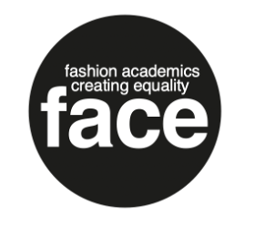

Gabrielle Miller

Gabrielle is an experienced practitioner, researcher, consultant and educator specialised in pedagogical development for Climate, Racial and Social Justice. She provides direction in higher education to collaboratively work towards embedding sustainability and anti-racism pedagogy into fashion practice. She brings expertise from her time working in fashion houses including Alexander McQueen and Givenchy, and has worked in sustainable design for ten years both teaching across UAL, and at research centres. Her work aims to disrupt and suggest ways forward through activism in education that addresses equity, belonging and justice by raising self-awareness of biases.

